What is TypeScript?
TypeScript is a syntactic superset of JavaScript which adds static typing.
This basically means that TypeScript adds syntax on top of JavaScript, allowing developers to add types.

Why should I use TypeScript?
JavaScript is a loosely typed language. It can be difficult to understand what types of data are being passed around in JavaScript.
In JavaScript, function parameters and variables don't have any information! So developers need to look at documentation, or guess based on the implementation.
TypeScript allows specifying the types of data being passed around within the code, and has the ability to report errors when the types don't match.
For example, TypeScript will report an error when passing a string into a function that expects a number. JavaScript will not.

What is type in Typescript?
In Typescript, type annotation is a way of explicitly specifying the type of variable, function parameter, or function return value.
Type annotation is expressed by using a colon (:) followed by the desired type after the variable or function parameter declaration. There can be a space after the colon.
Ex. let firstName:String = “Pratham”;
let n:number=10 ;

Type in Typescript:
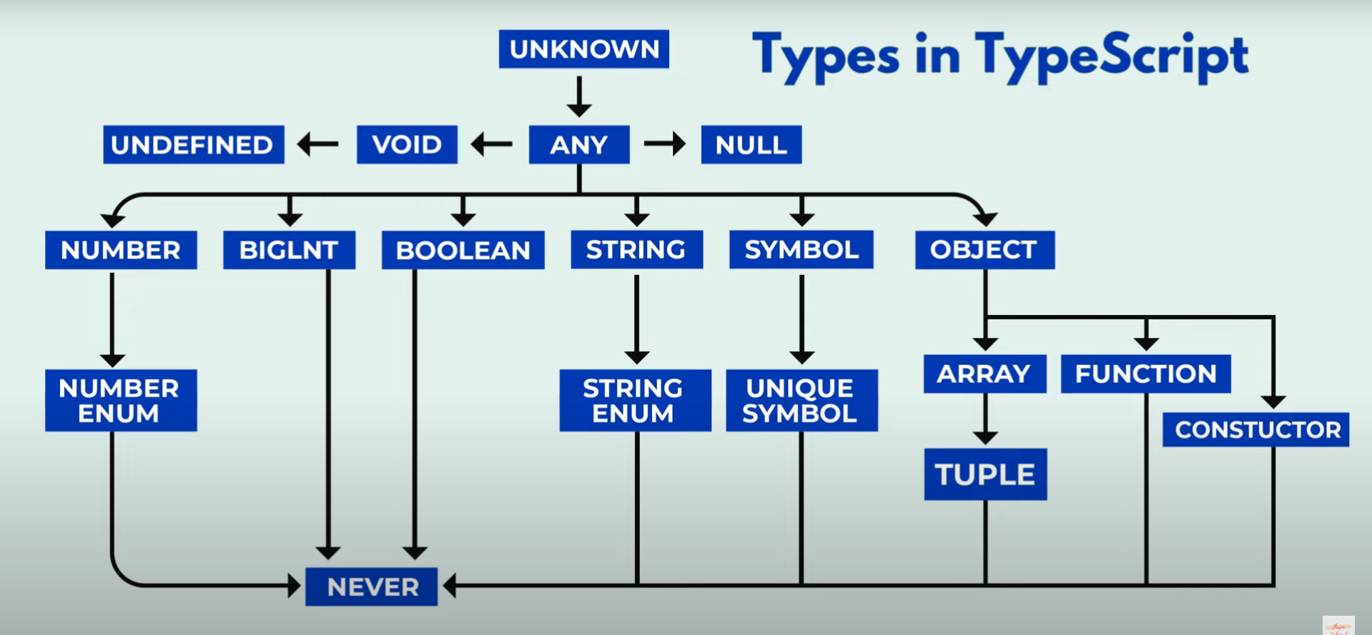

Number type:
- The number type represents numeric values, including integers and floating-point numbers.
- Number type in typescript support arithmetic operations such as addition (+), subtraction (-), multiplication (*), and division (/).
- The result of these operations on numbers also of type numbers.
- Ex.
  - let myFavNum: number = 5;
  - let myAge: number = 29;
  - let pi: number = 3.147;
  - let myNegVal: number = -5;

String type:
- Any value under single or double quotes are treated as string, Also any expression result string as output.
- Ex:
  - let name: String = “Pratham”;
  - let str: String = ‘abcd’;

Boolean type:
- In Typescript, the Boolean type represents a value that can be either true or false. It is one of basic primitive types in the language.
- Ex.
  - let isOdd: boolean = true;
  - let isDone: boolean = false;

BigInt Type:
- It is a build-in type that allows you to work with numbers that are larger than the range support by the regular number type.
- BigInt literals are written by appending the n suffix to an integer literal.
- In JS we can’t read the whole numbers beyond 2 raise to power 53.
- Ex.
  - let maxNumber: bigint = 9007199254740991n

Any type:
- The any type is the most flexible type in typescript. It essentially turns off all type checking for the variables or expressions it is applied to.
- You will see any type when u first write the code.
- Ex.
  - let myFavNum: any = 5;
  - myFavNum = “vinod”;
  - myFavNum = true;

Unknown type:
- The unknown type is a safer alternative to any because it still enforces type checking type safety.
- Variable of type unknown can hold values of any type, but you must perform type checks or type assertions before using them in specific ways.
- Ex.
  - let myFavNum: any = 5;
  - myFavNum = “vinod”;
  - myFavNum = true;

undefined & null
- undefined and null are types that refer to the JavaScript primitives undefined and null respectively.
- Ex.
  - let y: undefined = undefined;
  - let z: null = null;
- These types don't have much use unless strictNullChecks is enabled in the tsconfig.json file.

Array type:
- In typescript, an array is a data type that can store multiple values of different data types sequentially.
- We can create array
- using square brackets:
const numbers: number[] = [1, 2, 3, 4, 5, 6]; //square bracket

- using array constructor:
const numbers: number[] = (1, 2, 3, 4, 5, 6); //round bracket

- using Array.of method.
const numbers: string[] = Array.of(“vinod”, “karan”, “lalit”);
Array methods
array.push() //to add elements in array
array.pop() //to remove elements from array
array.length //to find length of an array

Tuples:
- In Typescript, tuples are a data structure that allows you to store a fixed-size collection of elements of different types.
- They are similar to arrays, but with a key difference: the types of elements in a tuple are fixed and declared at the time of creation, whereas arrays can hold elements of the same type, and their size can vary.
- define our tuple
let ourTuple: [number, boolean, string];
- initialize correctly
ourTuple = [5, false, 'Coding God was here'];
- Even though we have a boolean, string, and number the order matters in our tuple and will throw an error.

Objects:
- In typescript, objects are used to represent data with key-value pairs. Each key in the object is a string (or a symbol in ES6) that maps t a value.
const object ={
name: “Pratham”,
age: 24
}

Functions:
- TypeScript has a specific syntax for typing function parameters and return values.
- Return Type
function getTime(): number {
return new Date().getTime();
}
[ If no return type is defined, TypeScript will attempt to infer it through the types of the variables or expressions returned. ]
- Void Return Type
  - The type void can be used to indicate a function doesn't return any value.

function printHello(): void {
console.log('Hello!');
}

- Parameters
function multiply(a: number, b: number) {
return a * b;
}

- Optional Parameters
  - By default TypeScript will assume all parameters are required, but they can be explicitly marked as optional.
// the `?` operator here marks parameter `c` as optional
function add(a: number, b: number, c?: number) {
return a + b + (c || 0);
}

- Default Parameters
  - For parameters with default values, the default value goes after the type annotation
function pow(value: number, exponent: number = 10) {
return value ** exponent;
}

Type Aliases:
- In TypeScript, a type alias is a way to give a name to a specific type or combination of types. It allows you to create a custom name for a type, making it easier to reuse and refer to the same type in different parts of your code. Type aliases provide better readability, organization and abstraction of complex types.
- To define a type alias, you use the type keyword followed by the alias name and the type definition,

type Person = { //make sure aliases name starts with capital letter
name: string;
age: number;
isStudent: boolean;
address: { city: string; country: string }
}

Const person: Person = {
name: “Prathamesh”,
age: 27,
isStudent: true,
address: {
city: “pune”,
country: ‘India’
}
}

Method call signatures/ type alias:

- In TypeScript, a method call signature defines the types of arguments a function or method accepts, along with the type of value it returns. It's essentially a blueprint for how the function can be called.

type Calculator = {
add: (x: number, y: number) => number;
subtract: (x: number, y: number) => number;
};

